Traditional air balancing method

Proportional:

Proportional air balancing method is a widely used method for testing, adjusting and balancing (TAB). The principle of this method has been explained by ASHRAE, NEBB, ICBSE, SMACNA and etc. These descriptions are only a simple guideline rather than a complete algorithm. In practice, engineers must adjust according to their experiences to perform balancing. This would bring difficulties for analyzing the performance of this methods and compare with others. Therefore, it is necessary to convert the proportional method into an algorithm (pseudocode) at the beginning.

Based on the descriptions by ASHRAE, NEBB, ICBSE and SMACNA, the accepted common features for proportional methods include:

1. Balancing start from full open damper state.
2. Obtain the ratio of air flow rate with respect to the design value for each branch.
3. Adjust dampers such that their ratio approaches the same, (proportioning)
4. In order to save energy, at least one damper should remain fully open.
5. Adjust fans at last to achieve design air flow for all branches.
6. Maximum tolerance for relative error of any flow rates should be within +/-10%

Therefore, an algorithm can be firstly proposed:

N = number of dampers

for i from 1 to N

let p(i) = 0

set damper i position to p(i)

start fan and working at nominal fan speed

for i from 1 to N

q(i) = flow rate through damper i

t(i) = target flow rate for damper i

r(i) = q(i)/t(i)

error(i) = |q(i)-t(i)|/t(i)

errormax = maximum among error

while errormax > 10%

k = sorting index of r in ascending order

rmin = r(k(1))

for i from 2 to N

while r(k(i))>rmin

p(k(i)) increase by epsilon

set damper k(i) position to p(k(i))

pmin = minimum among p

for i from 1 to N

p(i) = p(i)-pmin

set damper i position according to new p(i)

qfan = measure fan outlet flow rate

ttot = target of total flow rate

while |qfan-ttot|/ttot>5%

if qfan>ttot

fan speed decrease by epsilon

else

fan speed increase by epsilon

for i from 1 to N

q(i) = flow rate through damper i

t(i) = target flow rate for damper i

r(i) = q(i)/t(i)

error(i) = |q(i)-t(i)|/t(i)

errormax = maximum among errors in all terminals

output final results

By simulating the above algorithm for ASHRAE example 8 in Matlab/Simulink environment using Simscape library, the results are shown as follows.

ProportionalMethod_ASHRAE_test_1

In ASHRAE example 8, the air balancing can be clearly separated into two branches: the upstream side of fan and the downstream side. The upstream part of the duct system contains three terminals, and the downstream part contains six terminals. The proportioning balancing algorithm is then performed on each part separately.

Test 1:

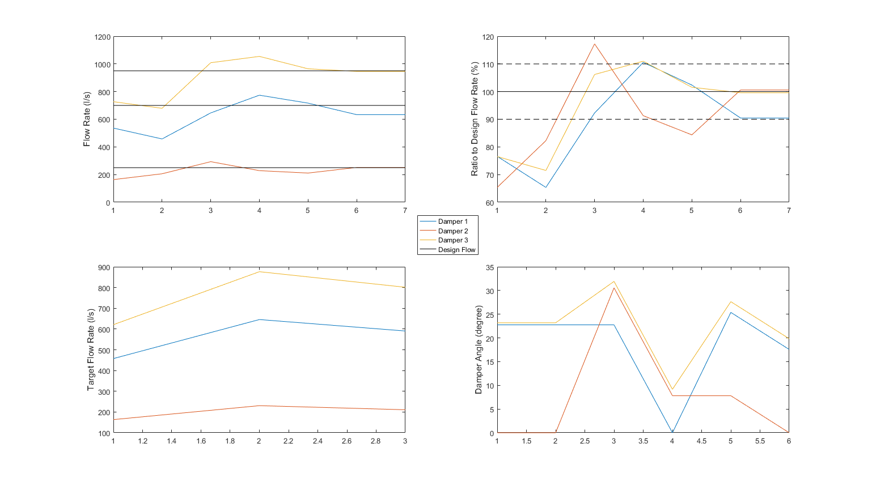

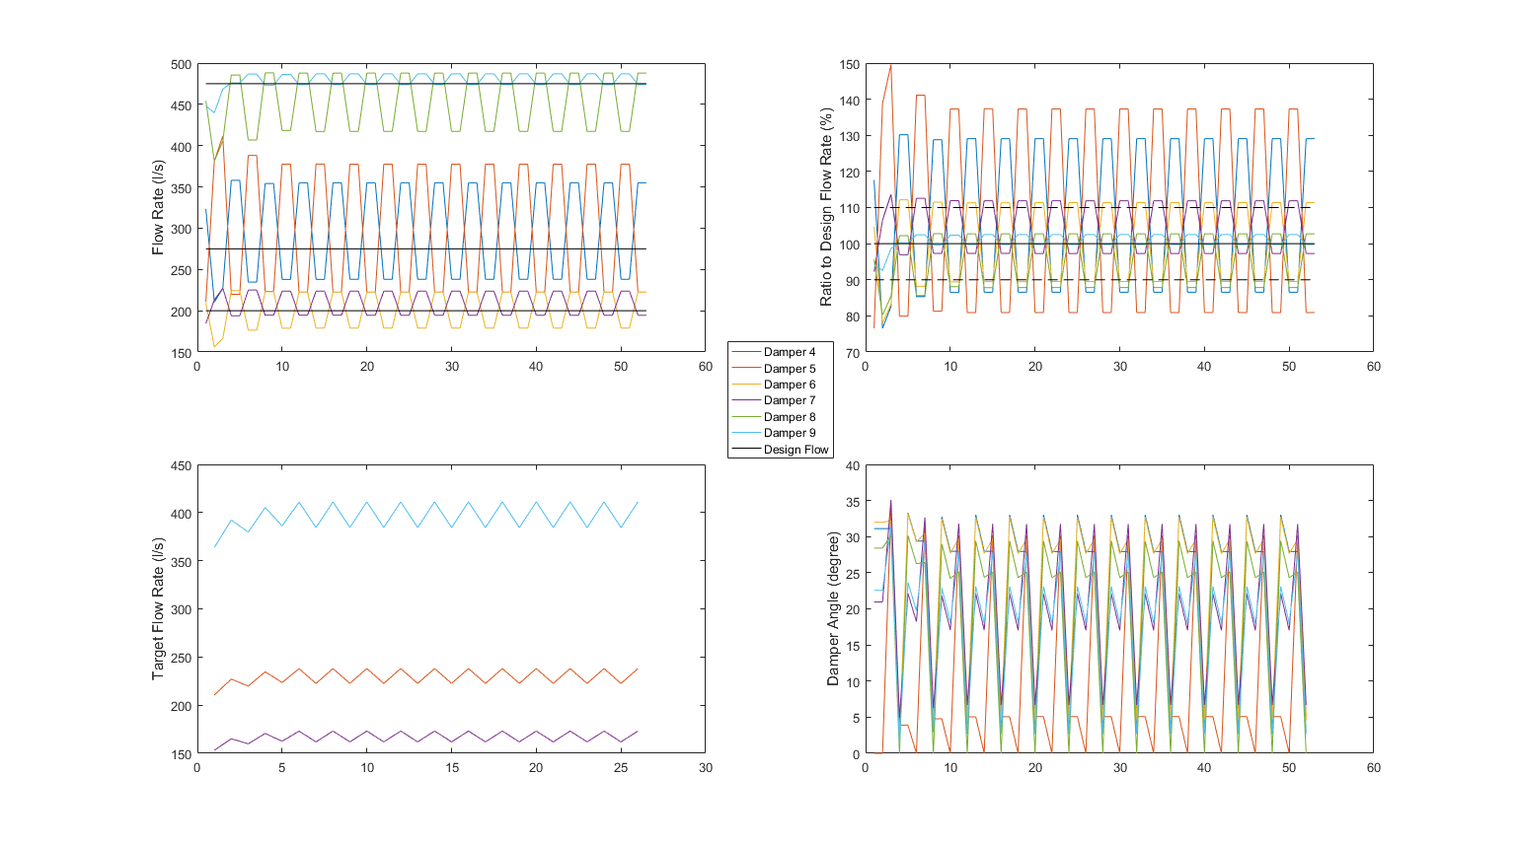

Data source: ASHRAE_Sim_ProportionalMethod_02092016021607.mat.

It can be seen that for branch 2, after several iterations, the damper adjustment reaches a relative stable circulation that changes around the target flow but never converge.

Further investigation reveals that the terminal with highest overflow ratio becomes the lowest in the next iteration. This indicates that the adjustment of the terminal directly to its desired airflow ratio may be over tuned. Therefore, we introduce a damping ratio lambda that balances between the current flow rate and the target flow rate. Detail algorithm is described as below:

N = number of dampers

lambda = 0.5

for i from 1 to N

let p(i) = 0

set damper i position to p(i)

start fan and working at nominal fan speed

for i from 1 to N

q(i) = flow rate through damper i

t(i) = target flow rate for damper i

r(i) = q(i)/t(i)

error(i) = |q(i)-t(i)|/t(i)

errormax = maximum among error

while errormax > 10%

k = sorting index of r in ascending order

rmin = r(k(1))

for i from 2 to N

let rtarget=lambda*rmin+(1-lambda)*r(k(i))

while r(k(i))>rtarget

p(k(i)) increase by epsilon

set damper k(i) position to p(k(i))

update q(k(i)) = flow rate through damper k(i)

update r(k(i)) = q(k(i))/t(k(i))

pmin = minimum among p

for i from 1 to N

p(i) = p(i)-pmin

set damper i position according to new p(i)

qfan = measure fan outlet flow rate

ttot = target of total flow rate

while |qfan-ttot|/ttot>5%

if qfan>ttot

fan speed decrease by epsilon

else

fan speed increase by epsilon

for i from 1 to N

q(i) = flow rate through damper i

t(i) = target flow rate for damper i

r(i) = q(i)/t(i)

error(i) = |q(i)-t(i)|/t(i)

errormax = maximum among errors in all terminals

output final results

In the second test, the damping ratio is set to be lambda=0.5 and the results are shown below:

ProportionalMethod_ASHRAE_test_2

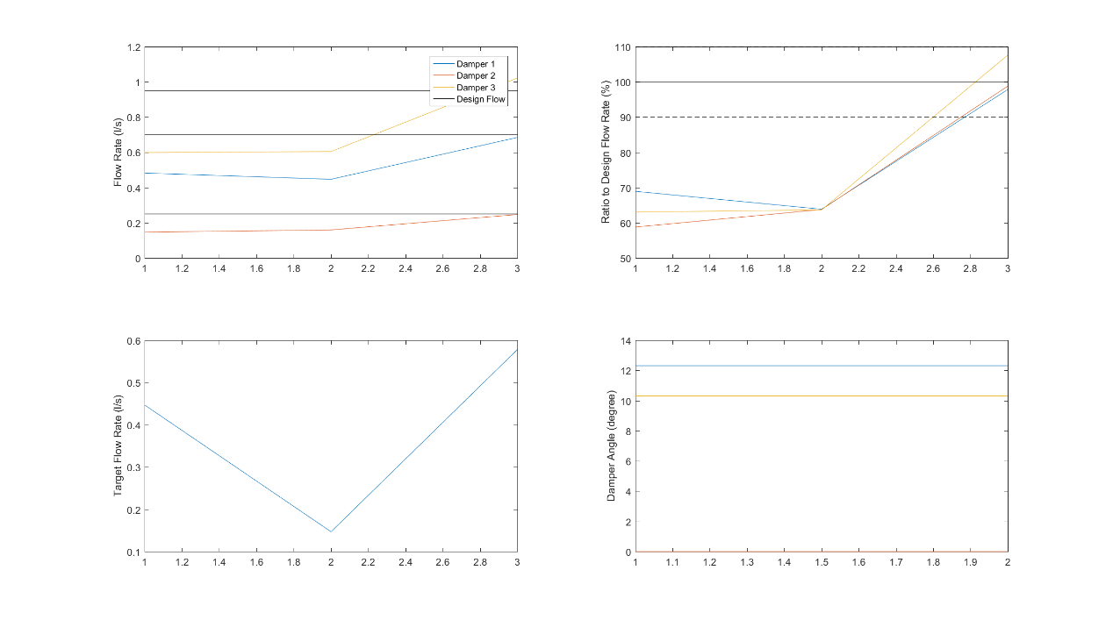

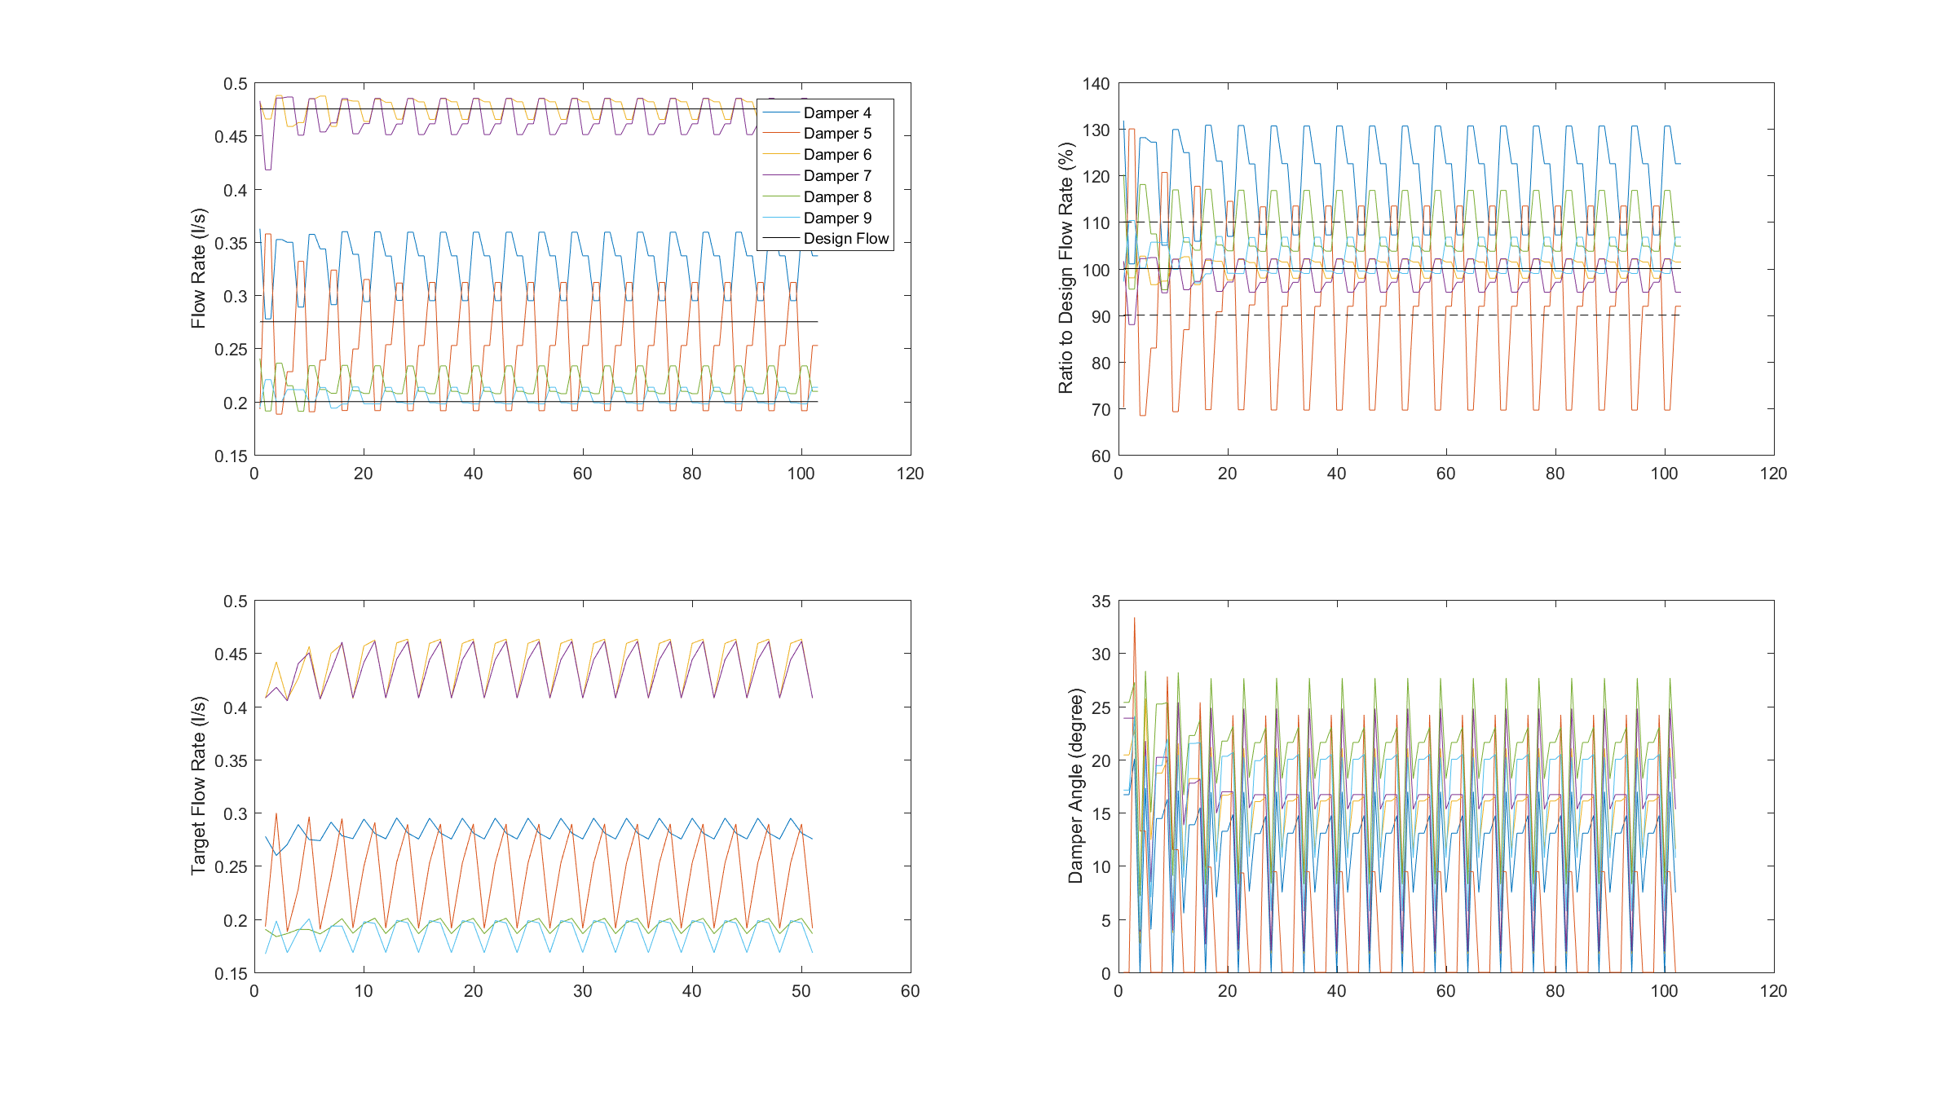

Data source: ASHRAE_ProportionalMethod_19092016191800.

It is obvious that the terminal with the highest flow ratio is no longer the lowest in the second iteration. However, after several iterations of changes, the situation becomes the same, and the result is still a recurrent adjustment. Probably the damping ratio is not sufficient enough and in the third test, the damper ratio will be set to lambda=0.3.

ProportionalMethod_ASHRAE_test_6

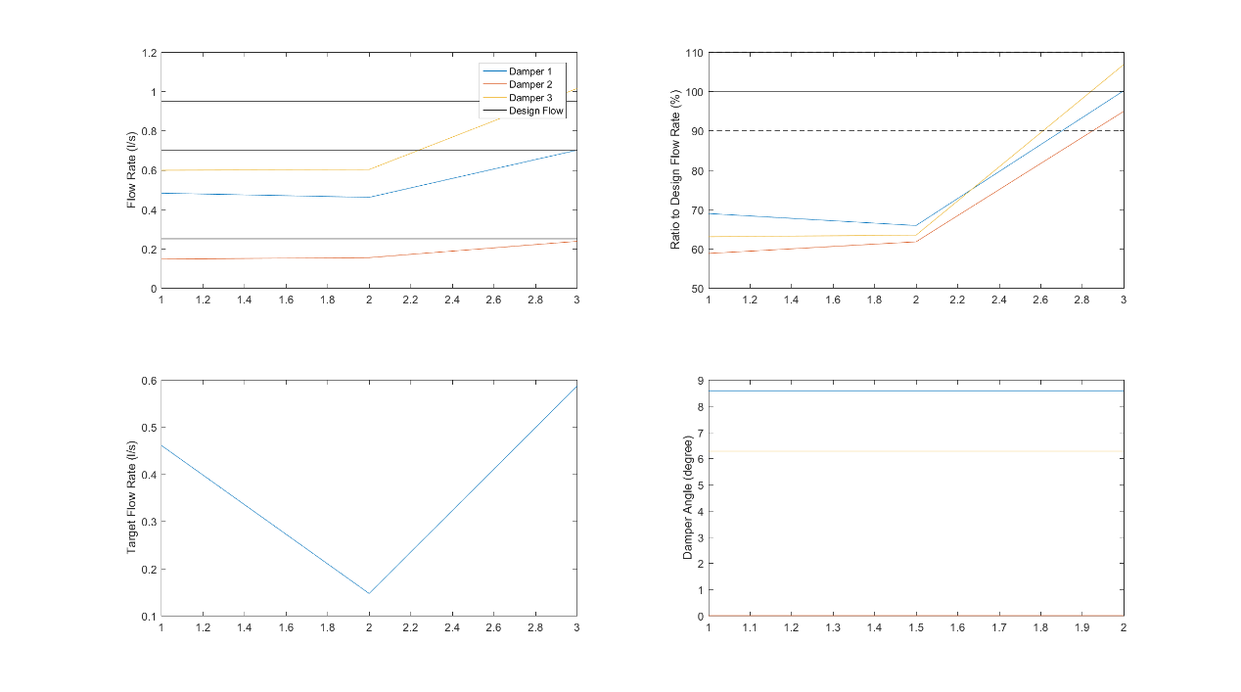

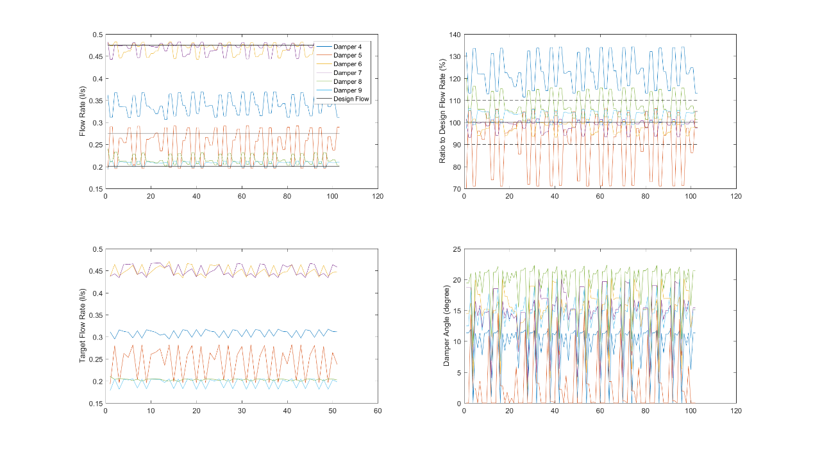

Data source: ASHRAE_ProportionalMethod_19092016192916.

ProportionalMethod_ASHRAE_test_3

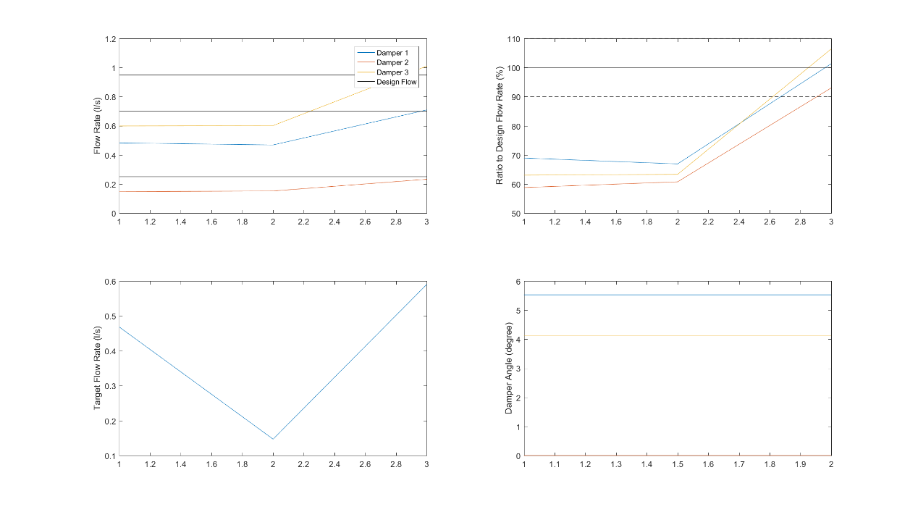

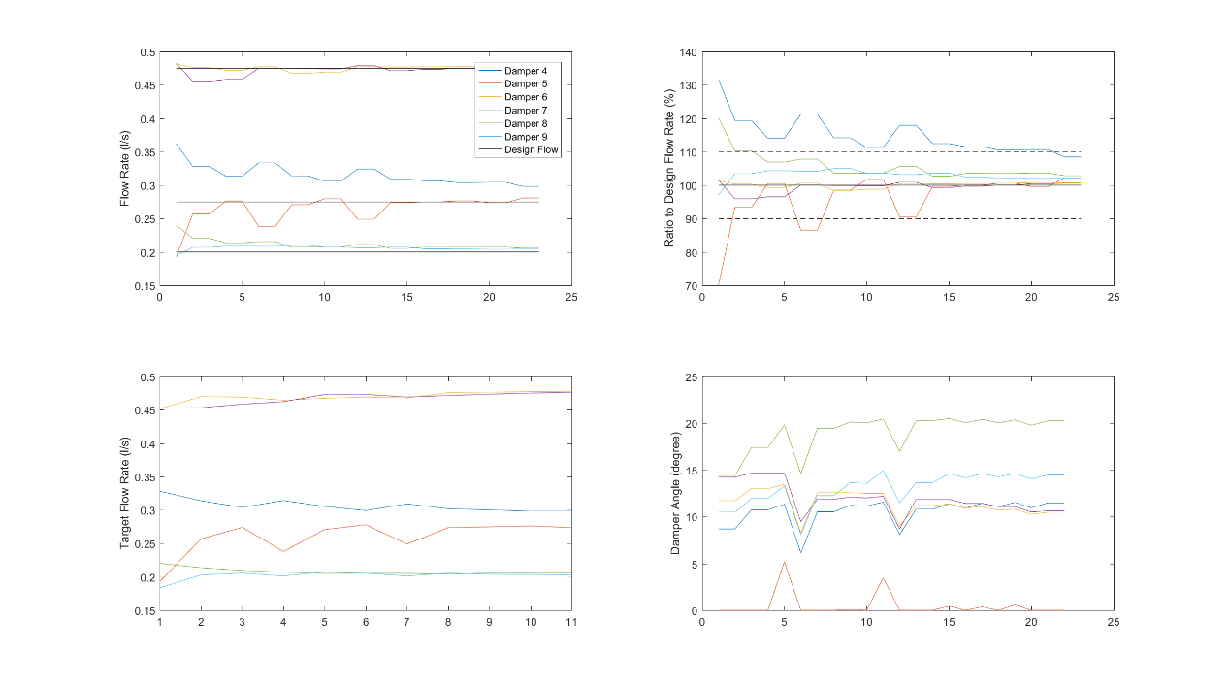

Data source: ASHRAE_ProportionalMethod_19092016192009.

The results have improved and the proportional method firstly converges. Other damping ratio should be investigated in the next test. lambda=0.1;

ProportionalMethod_ASHRAE_test_4

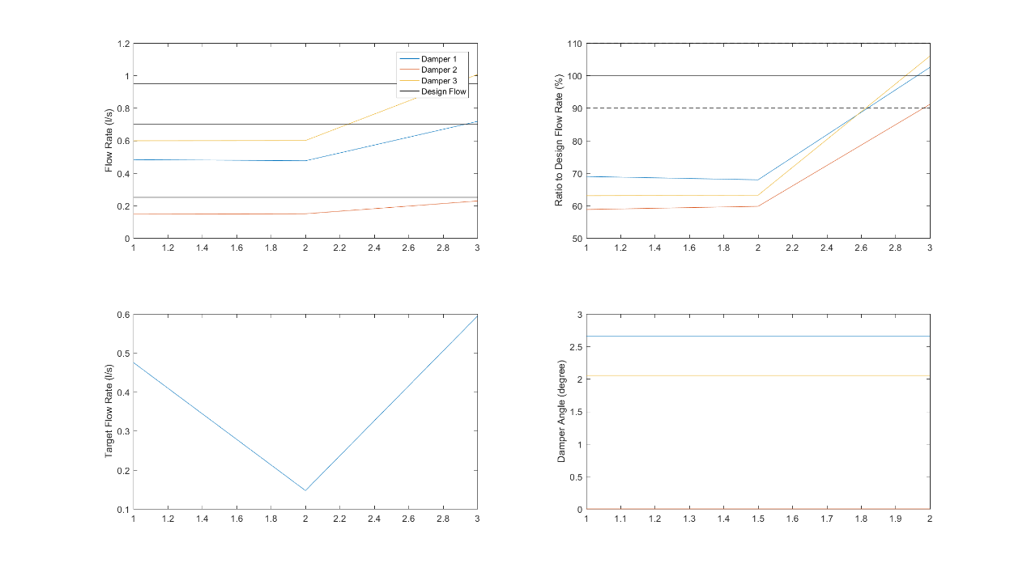

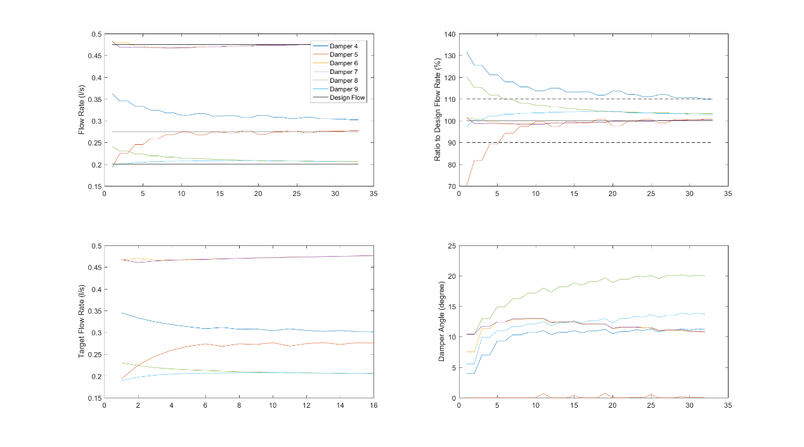

Data source: ASHRAE_ProportionalMethod_19092016183757.

The result seems improved and convergence faster. It can be seen that during 10-40 period, the adjustment reduces the damper 6(yellow) down to zero gradually and start to tune the damper 5(orange). We also tried lambda=0.05. The convergence becomes slow because the step size in each iteration is limited

ProportionalMethod_ASHRAE_test_5

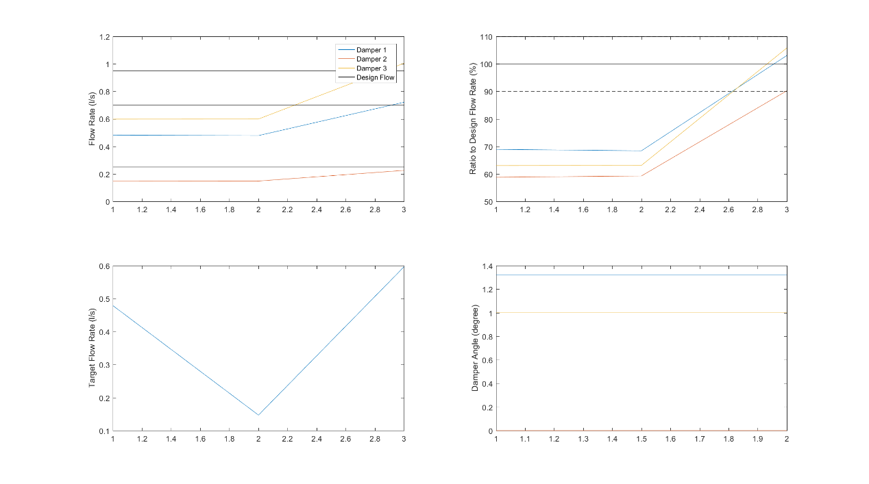

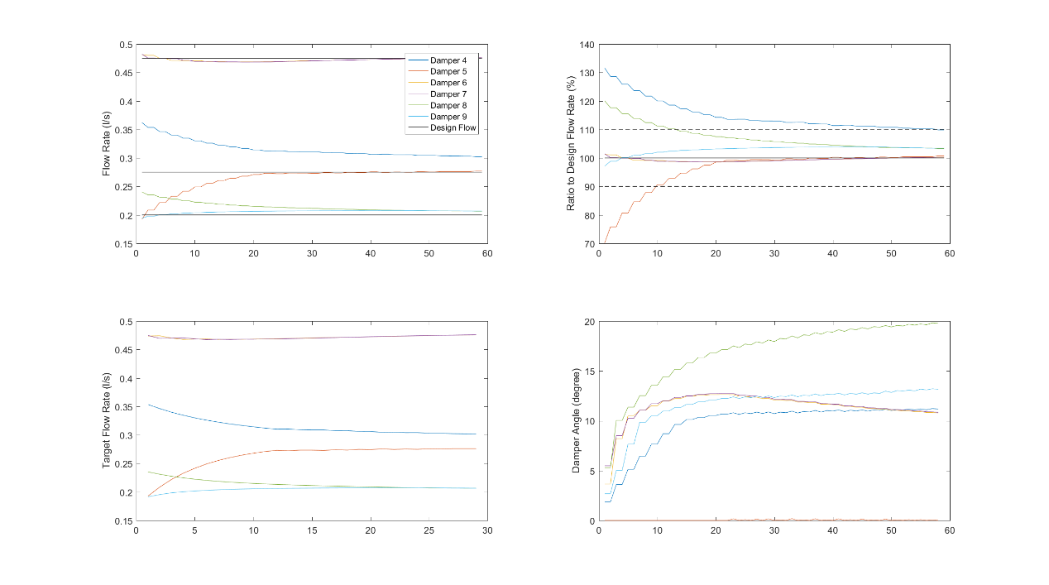

Data source: ASHRAE_ProportionalMethod_19092016192300.

From the result. We can find out that the difficulty exists in this method is to maintain one damper to be fully open. When the initial fully open damper is happened to be the true fully open damper, the convergence can be very easy. However, if the true fully open damper is has firstly wrongly closed, it could be very difficult for the proportional method to find out the damper that should be fully open.

Finally we choose lambda=0.1 as the standard proportional method.